# DEPARTMENT OF INFORMATION TECHNOLOGY

**COURSE CODE: DJS22ITL5013 DATE: 18-10-24**

**COURSE NAME: Statistical Analysis Lab CLASS: T.Y. BTech**

**NAME: Anish Sharma DIV: IT 1-1 ROLL: I011**

# EXPERIMENT NO.07

**CO 2:** Perform Test of Hypothesis for independence and appropriateness of distribution using various statistical techniques.

**AIM / OBJECTIVE:** To implement ANOVA using SPSS

# DESCRIPTION OF EXPERIMENT:

1. ANOVA in SPSS is used for examining the differences in the mean values of the dependent variable associated with the effect of the controlled independent variables, after taking into account the influence of the uncontrolled independent variables.
2. Essentially, ANOVA in SPSS is used as the test of means for two or more populations. ANOVA in SPSS must have a dependent variable which should be metric (measured using an interval or ratio scale). ANOVA in SPSS must also have one or more independent variables, which should be categorical in nature. In ANOVA in SPSS, categorical independent variables are called factors. A particular combination of factor levels, or categories, is called a treatment.

# INPUT DATA / DATASET:

## Steps:

1. Select appropriate dataset. (different for each test)
2. Perform the 8 steps of hypothesis testing:

Step 1. Establish a null and alternative hypothesis. Step 2. Determine the appropriate statistical test. Step 3. Set the value of alpha, the Type I error rate. Step 4. Establish the decision rule.

Step 5. Gather sample data. Step 6. Analyze the data.

Step 7. Reach a statistical conclusion. Step 8. Make a business decision

1. Perform the following tests using Excel and SPSS :

The following steps reflect SPSS’s dedicated One-Way ANOVA procedure. However, since the One-Way ANOVA is also part of the General Linear Model (GLM) family of statistical tests, it can also be conducted via the Univariate GLM procedure (“univariate” refers to one dependent variable). This latter method may be beneficial if your analysis goes beyond the simple One-Way

ANOVA and involves multiple independent variables, fixed and random factors, and/or weighting variables and covariates (e.g., One-Way ANCOVA). We proceed by explaining how to run a

One-Way ANOVA using SPSS’s dedicated procedure.

1. To run a One-Way ANOVA in SPSS, click Analyze > Compare Means > One-Way ANOVA.
2. Put columns in dependency list and factor list
3. Click OK

The One-Way ANOVA window opens, where you will specify the variables to be used in the analysis. All of the variables in your dataset appear in the list on the left side. Move variables to the right by selecting them in the list and clicking the blue arrow buttons. You can move a variable(s) to either of two areas: Dependent List or Factor.

One-Way ANOVA dialog window.

A Dependent List: The dependent variable(s). This is the variable whose means will be compared between the samples (groups). You may run multiple means comparisons simultaneously by selecting more than one dependent variable.

B Factor: The independent variable. The categories (or groups) of the independent variable will define which samples will be compared. The independent variable must have at least two categories (groups), but usually has three or more groups when used in a One-Way ANOVA. C Contrasts: (Optional) Specify contrasts, or planned comparisons, to be conducted after the overall ANOVA test.

One-way ANOVA: Contrasts dialog window.

When the initial F test indicates that significant differences exist between group means, contrasts are useful for determining which specific means are significantly different when you have specific hypotheses that you wish to test. Contrasts are decided before analyzing the data (i.e., a priori).

Contrasts break down the variance into component parts. They may involve using weights, non- orthogonal comparisons, standard contrasts, and polynomial contrasts (trend analysis).

Many online and print resources detail the distinctions among these options and will help users select appropriate contrasts. For more information about contrasts, you can open the IBM SPSS help manual from within SPSS by clicking the "Help" button at the bottom of the One-Way ANOVA dialog window.

D Post Hoc: (Optional) Request post hoc (also known as multiple comparisons) tests. Specific post hoc tests can be selected by checking the associated boxes.

One-way ANOVA: Post Hoc Multiple Comparisons dialog window.

1. Equal Variances Assumed: Multiple comparisons options that assume homogeneity of variance (each group has equal variance). For detailed information about the specific comparison methods, click the Help button in this window.
2. Test: By default, a 2-sided hypothesis test is selected. Alternatively, a directional, one-sided hypothesis test can be specified if you choose to use a Dunnett post hoc test. Click the box next to Dunnett and then specify whether the Control Category is the Last or First group, numerically, of your grouping variable. In the Test area, click either < Control or > Control. The one-tailed options require that you specify whether you predict that the mean for the specified control group will be less than (> Control) or greater than (< Control) another group.
3. Equal Variances Not Assumed: Multiple comparisons options that do not assume equal

variances. For detailed information about the specific comparison methods, click the Help button in this window.

1. Significance level: The desired cutoff for statistical significance. By default, significance is set to 0.05.

When the initial F test indicates that significant differences exist between group means, post hoc tests are useful for determining which specific means are significantly different when you do not have specific hypotheses that you wish to test. Post hoc tests compare each pair of means (like t- tests), but unlike t-tests, they correct the significance estimate to account for the multiple comparisons.

E Options: Clicking Options will produce a window where you can specify which Statistics to include in the output (Descriptive, Fixed and random effects, Homogeneity of variance test, Brown-Forsythe, Welch), whether to include a Means plot, and how the analysis will address Missing Values (i.e., Exclude cases analysis by analysis or Exclude cases listwise). Click Continue when you are finished making specifications.

**OBSERVATIONS / DISCUSSION OF RESULT:**

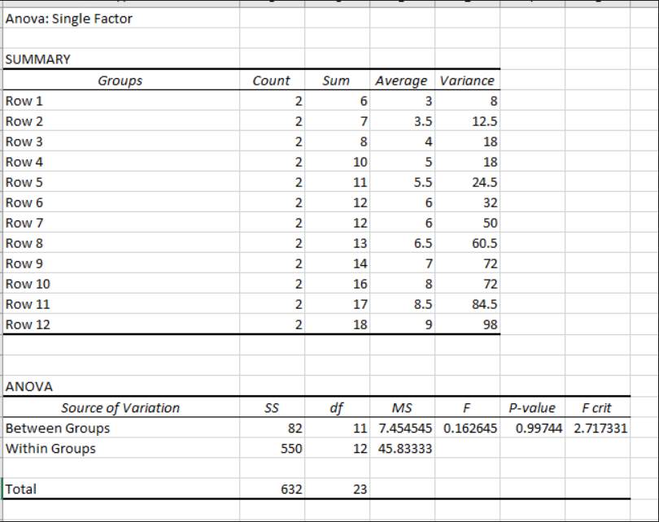

# 

# CONCLUSION:

In this experiment, we implemented ANOVA using SPSS

# REFERENCES:

Bhattacharyya, G. K., and R. A. Johnson, (1997). Statistical Concepts and Methods, John Wiley andSons, New York.

## Website References:

1.      Chapter 2 Lab 2: Descriptive Statistics | Answering questions with data: Lab Manual (crumplab.com)

2.      https://www.webpages.uidaho.edu/~stevel/251/Utts/R/chapter%2011.pdfhttps://onlinestatb ook.com/ 2/estimation/mean.htmL